8. ASANAS IN ( SUPINE POSITION ) SLEEPING POSE

Sarvangasan

Introduction : We have studied this asana in detail in the syllabus of Yoga Pravesh, hence no further information or discussion is required in this syllabus. However, the duration of this asana was fixed as 3 minutes during Yoga Pravesh studies, which should be increased to 5 minutes in the yoga parichay. It is easily possible to increase the duration having had enough practice during Yoga Pravesh. However, attention has to be paid towards achieving the ideal pose of the asana.
References in the ancient texts: This asana has not been described under its name in any of the ancient texts of yoga. However, a mudra known as Viparit Karani fits the description of this asana. We will see the references to the Viparit Karani while studying Shirshasan and hence it is not discussed here.

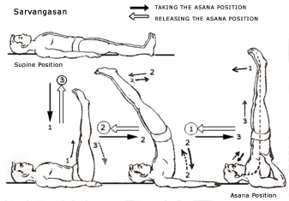

Matsyasan

Introduction : We have studied this asana too in Yoga Pravesh studies. The performance of the asana, its physical effects etc have already been discussed.
References in the ancient texts : The asana has been described in the second chapter of the Gherandsamhita as under :
Muktapadmasanam krutva uttanshayanam charet |
Koorparabhyam shiro veshtyam rogaghanam matsyamasanam || G S 2.21
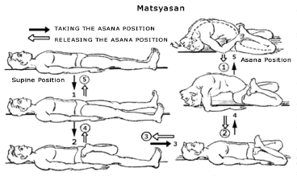

Meaning : Performing Mukta Padmasan ( not Baddha Padmasan but Simple Padmasan ), sleep on the back and turn the head backwards with the help of both the elbows. This asana is termed as Matsyasan and eliminates diseases.
This description does not specifically state that the fontanelle is to be touched to the ground. But it states that help of the elbows is to be availed while turning the head. Hence, it must be expected that the shoulders should be lifted, the neck turned so as to touch the fontanelle onto the ground. Otherwise, the help of the elbows is not required. But the shloka does not state which diseases are eliminated. We cannot generally state that all types of disease are eliminated by performance of this asana , but we can say that with the daily practice of this and the other asanas, the possibility of catching diseases is minimized. Sarvangasan acts on thyroid and pituitary glands. This asana too acts on these glands in a particular manner and the layers in these glands get rubbed against each other thereby increasing the efficiency of the flow of the fluids secreted by these glands, which generally has a good effect on the health of our body.

Halasan

Introduction : This asana has already been described in the previous syllabus. However, if the position of the legs in this asana is changed to a little extent, the level of strain on different spinal vertebrae can also be changed. With this aspect in mind, the asana has been enumerated here again.
Pre position : Sleeping Pose
Performing the asana pose : 1. First exhale. Then while inhaling gradually lift both the legs, till a right angle is formed with the ground level. This is the position of Dwipad Uttanpadasan.
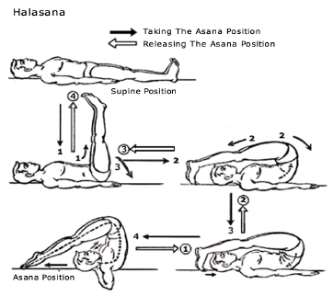
2. Exhaling bend the legs at the waist and try to touch the toes to the ground beyond the head. Here efforts should be made to lifts the waist and the back bone to the minimum possible extent. The fold at the waist should be more , legs should be straight at the knees. Jalandhar Bandh is not achieved in the position as the spinal column is lifted to the minimum possible extent.
3. When a steady position is attained in the above-mentioned pose, try to bring the toes near the head. This will automatically result in touching some of the vertebrea of the slightly lifted spine to the ground. At the same time, there will be maximum bend in the waist. The knees should be kept straight.
4. Now try to stretch the feet and turn the toes away from the head as far as possible. Lift up the hands and place them below the neck. This will result in lifting the spine as well as the waist. It will also facilitate the stretching of the toes away from the head. The chin will rest on the chest and the Jalandhar Bandh will be automatically formed. When the pose is steady, breathe should be normal.
Releasing the asana pose : 1. Bring both the hands in place again. This will result in bringing the toes a little towards the head, but do not let the legs bend in the knee.
2. Gradually try to rest the spine on the ground while inhaling. Lift up the toes from the ground and attain the pose of Dwipad Uttanpadasan.
3. Start exhaling and gradually rest both the legs onto the ground so as to revert back to the sleeping position.
Important aspects in asana pose: While performing Halasan, we tried to achieve firm pose at three different stages. First, we tried to achieve maximum bend in the waist with only a little lifting of the spine. Then we tried to increase the bend in the waist while touching the spine to the ground by shifting the toes near the head. Thirdly we tried to turn the soles as much away as possible from the head, while lifting the spine and the waist from the ground. In all the three stages, it is important to keep the knees straight. It is also important that during the third stage, the Jalandhar Bandh is to be achieved automatically. Attention has also to be paid to the fact that during the first two stages, the chest should remain somewhat parallel to the ground, the vertibrae of neck and below should touch the ground and the Jalandhar Bandh is not formed. In these two stages, the fold or bend in the waist is more important.
Duration: During the first two stages of the halasan, duration of 15 to 30 seconds for each pose is essential. In the third stage, steady pose for duration of 2 minutes will bestow maximum benefits. The third stage entails keeping of palms below the neck and the toes away from the head. Duration of 2 minutes in such a steady pose is essential. Normal breathing while staying steady in the third pose is also important.
Physical Effects : The effects of the halasan as enumerated in the syllabus of Yoga Pravesha are stronger after performing the third stage. During the first two stages, a systematic pressure on different spinal vertebrae is observed which helps in increasing their efficiency. In the first stage, pressure is felt on the vertebrae in the middle. The second stage shifts the pressure onto the vertebrae near the waist, while in the third stage; the pressure is shifted to the vertebrae near the neck portion. Thus, all the three stages together exert pressure on the total spinal column, which results in increasing the elasticity of the entire spinal column. The other effects of the halasan have been already enumerated in the book Yoga Pravesh.
References in the ancient texts : The mention of this asana is not found in either Gherandsamhita or Hathapradeepika. However, it is certain that the asana has evolved out of hathayoga and has been taught traditionally by the masters (Guruparampara). However, both the texts do not have any shloka mentioning or describing this asana. The reason for this is not known.

Vistrutapada Halasan

Introduction : We have studied Halasan in the syllabus of Yoga Pravesh. The advanced stage of Halasan, stretching both the legs to the maximum is known as Vistrutpada Halasan. All other points related to Halasan such as attaining the pose, releasing the pose, stages, physical effects etc are applicable to this asana too.
Pre-position : Supine Position.

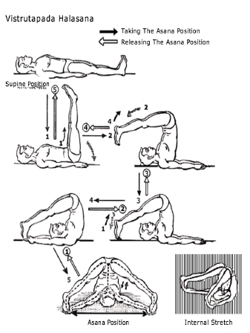
To perform the asana :
1. Exhale and while inhaling lift the legs and keep them at a right angle to the ground. That is assume the pose of Dwipad Uttanpadasan.
2. Lift the waist while exhaling and keep the legs floating behind the head. The body has to retain its balance.
3. Exhaling completely, touch the toes of the legs to the ground; the heels will be straight up.
4. With both the hands, hold the toes of the legs.
5. Stretch away the legs from each other at the maximum possible distance keeping them straight at the knees. Hands should hold the toes and breathe should be normal.
To release the asana :
1. While holding the toes of the legs with the hand, try to join the legs to each other.
2. Release the toes and bring back the hands in their earlier pose i.e. supine position.
3. Exhale and while inhaling lift up the legs without bending them at the knees.
4. Resume the pose of Dwipad Uttanpadasan while inhaling.
5. Exhale and touch the legs to the ground, coming back into the supine position.
Important aspects of the asana pose: The heels of the legs are to be kept upright while performing this asana. In Yoga Pravesh syllabus, during performance of Halasan, the toes were stretched. The hands were straight and the toes were stretched and thus, there was creation of pressure, working in opposite direction. Here, we are holding the toes with the hands and the toes and heels are kept upright without stretching them. The legs are moved away from each other without bending them in the knees. If the legs are bent at the knees, the body may lose its balance regaining its earlier pose. At this stage of the asana, the shoulders, the vertebrae of the neck, the head, both the toes of the legs and two hands touch the ground. As in Halasan, here also the chin is pressed on to the chest and the Jalandhar Bandh is fixed automatically. When the legs are stretched away from each other, pressure is created in the body. Since the hands are stretched over the head, it is difficult to keep the balance of the body. Hence, proper attention must be paid while performing this asana towards keeping the balance. and be steady in the posture.
Duration: In this asana, after attaining the pose of Halasan, a more difficult pose is attained while retaining the balance of the body. Hence, to perform this asana, perfect posture in Halasan should be learnt first. If the accurate position in Halasan can be maintained with confidence for some duration, this asana can be performed effectively. When Halasan is perfected, we will be able to retain a steady pose in this asana for a few seconds. After further practice, it is necessary, that the duration of 30 seconds is maintained in this asana, so as to enjoy its benefits. After study and practice in depth, the duration can be increased to 1.5 to 2 minutes.
Physical Effects: The effects on the spinal column, which arise while performing Halasan will also, be evident while performing this asana. The increase in the flexibility and the efficiency of the column is also another benefit of this asana. The benefits of Jalandhar Bandh can also be experienced in this asana. Also, when the legs are stretched away from each other, the main muscles and joints of the waist are pressurized and there is an increase in their efficiency. In Halasan, these muscles and joints are only flexed forward and backward, in this asana, they are stretched towards both the sides. This not only increases their efficiency, but also erases any defects. The result of these actions of the joints and joints is shifting the pressure on the joints of the abdomen and the digestive system and in turn increasing the efficiency of the overall digestive system.
Precaution: All the caution exercised while performing Halasan, has to be observed for this asana too. But this asana involves assuming an advanced stage, which creates a pressure on the muscles of the waist. Hence, persons suffering from diseases of those muscles should not strive to shift their legs too much. They should limit the shifting of the legs as per their individual capacity. Otherwise instead of benefits, they will have to face the disadvantages. Also, persons suffering from ailments of digestive system should seek advice from Yoga experts before performing this asana. Those who suffer from inflammation of the intestines, diseases of kidneys, spleen or liver etc should not try to perform this asana.
References in the ancient texts: Like Halasan, this asana too has not been described in the ancient texts of Hathyoga. It is not mentioned in Hathapradeepika or Gherandsamhita. However, as it denotes an advanced stage in Halasan, its performance is useful. However, the texts do not mention it.

Karnapeedanasan

Introduction: As Vistrutapada Halasan is an advanced stage of Halasan, so is Karnapeedanasan. From the name, it is presumed that the asana involves some trouble to the ears, however it is not so. While performing this asana, the knees are moved towards the ears. Otherwise, there is no concern of the ears. However, it is commonly known by this name only.
Pre-position: Supine position
To perform the asana: 1. Exhale and while inhaling lift the legs and keep them at a right angle to the ground that is assume the pose of Dwipad Uttanpadasan. 2. Lift the waist while exhaling and keep the legs floating behind the head. The body has to retain its balance.
3. Exhaling completely, touch the toes of the legs to the ground; stretch the toes. Let the breath be normal. This is the pose of Halasan.
4. Bend both the legs in the knees and bring the heels near the head. Try to rest the knees to the ground near the ears. The hands will be kept as in supine position. The breath should be normal.
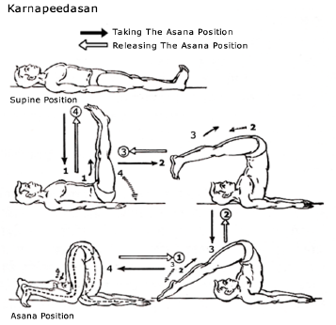
To release the asana :
1. Straighten out the legs at the knees and stretch backwards. That is come back to the position of Halasan.
2. Exhale and while inhaling, lift up the legs from the ground and keep them straight, without bending in the knees.
3. Resume the position of Dwipad Uttanpadasan, by touching the spinal column onto the ground while inhaling.
4. Touch the legs to the ground, back into the supine position while exhaling.
Important aspects of this asana pose :The hands are kept as in supine pose while being in this asana. The legs are to be bent in the knees. The waist and the spinal column also are to be bent as per the need. The knees are to be touched to the ground near the ears. This requires stretching of the toes and touching their nails on the ground. Even if in the beginning, the knees do not touch the ground, an effort is required to be made. As in Halasan, the Jalandhar Bandh is fixed in this asana too. The spinal column is required to be bent a bit more in this asana. The bending will depend upon the length of the legs of the performer. If the legs are too long, the spinal column may remain straight. If the legs are short, it may have to be bent more. The bending of the spinal column is not important. The most important thing is to touch the knees to the ground.
Duration : When the asana can be performed perfectly, the duration can be easily increased. However, it is difficult to attain a steady position in this asana, till the time knees do not touch the ground. Hence, attention has to be paid to touching the knees to the ground. After that is achieved, the duration has to be kept for at least 30 seconds. With practice, the duration can be increased to 1 / 1.5 minutes. When the knees touch the ground, the unnecessary strain in the body can be minimized and a firm pose in the asana can be attained.
Physical Effects : All the benefits and effects of Halasan can be experienced in this asana too. But since both the knees have to touch the ground, more bends in the spinal column is necessary. So there are beneficial effects on the column. However, the pressure on the abdominal muscles and on the digestive system is not increased.
Precaution : This asana can be performed only after expertise in Halasan is achieved. The body should not be unnecessarily stretched to touch the knees to the ground. As the practice is continued, the knees will touch the ground and the asana can be performed easily. This asana is banned for people having trouble with spinal column.

Ardhachakrasan

Introduction : This is the preliminary stage of Purnachakrasana. However, in Purnachakrasan, the body turns circular and can be viewed as a circular shape. In comparison, during Ardhachakrasan, the body does not form a shape of half circle. However, as it is the first stage of Purnachakrasan, it is termed as Ardhachakrasan. The purpose of this asana is not limited to its utility as precursor of Purnachakrasan. This is an independent asana by itself and has important effects on the body. Hence, it has to be studied as an independent asana too.
Preposition : Supine Position.
To perform the asana pose :
1. Bend both the legs at the knees and bring them near the body. The soles of the feet should be flat on the ground. The legs should touch each other and being in the same position, the heels should touch the buttocks.
2. Fold both the hands above the head in Swastik Bandh.
3. Exhale. And inhaling, lift up the waist so as to bring the body from the knees to the shoulder in a straight position. Swastik Bandh of the hands and the heels of both the legs should remain touching the ground and the knees should touch each other.
4. Lift up the left leg and straighten it out at the knee, stretching the toes towards the front.
5. Lift up the heels of the right leg from the ground. Try to retain a firm position while balancing the body. Keep breath normal.
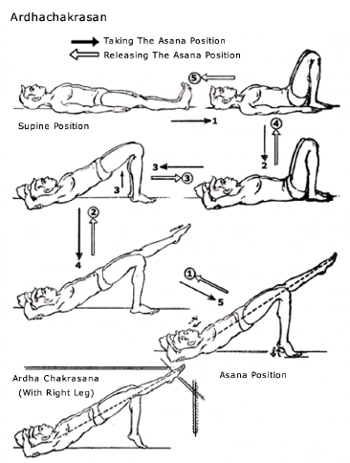

To release the asana pose:
1. Touch the heel of the right leg to the ground.
2. Bend the right leg at the knee and touch the heels of the left leg onto the ground near the right leg.
3. Gradually touch the waist to the ground and then the back.
4. Unfold the hands and regain the supine position.
5. Straighten out the legs to gain the complete supine position.
This asana can also be performed by lifting right leg fully, touching the toes of the left leg to the ground.
Important aspects of the asana : It is important that the straightened out leg, waist and the back should be in a straight line. It is difficult to balance the body while lifting the toes of the other leg. Hence, in the initial stage, keeping the soles of the feet flat on the ground may perform the asana. When that pose is firmly achieved, then the heel can be lifted and balance may be attained. The straightened out toes, back and the leg has to be stretched in a straight line. Also after attaining the position, it is important that gradual breathing should be continued and all the muscles be relaxed. Many muscles of the body are unnecessarily tensed. It is important to reduce the strain on them. However, while trying to release the strain, the asana pose should not be altered. The body has to be in a straight line from the shoulder to the legs while reducing the strain. The muscles of the face and those of the hands need not feel any strain. However, these muscles do feel some reactionary strain. At least this strain should be minimized in the beginning. Then the strain on the other muscles should be reduced with some efforts.
Duration: When the asana can be performed with ease, it is necessary to retain a firm pose for at least 30 seconds. Then the desired effects of the asana can be experienced. For further benefits, the asana should be performed for 3 minutes. Those who want to gain special effects of this asana can increase its duration with further efforts.
Physical Effects: The main effect is on the joints of the bones of the waist and the muscles surrounding that area. In those disease, where the joints of the waist require movement in particular direction, but the joint cannot bend in forward direction, can experience benefits from performing this asana. In this asana, muscles of the waist balance the bulk of the body weight against gravitational force. Hence, all these muscles get accustomed to bearing the weight, balancing it and keeping it steady against the force of gravitation. This increases their strength and the efficiency. When only the waist is lifted, the muscles have to bear the strain only for a few seconds and might not gain much from the exercise., however, here a major portion of the body weight is lifted and balanced and the muscles have to fight the gravitational force while achieving this feat. This results in increase in their efficiency. Movement of only waist may not increase the efficiency of these muscles. Hence, balancing and retaining a firm pose in this asana is necessary. When one leg is lifted and the heel of the other is also lifted, there is powerful and effective stress on the waist muscles.
This asana also involves some strain on the muscles of the calf muscles and the thighs. However, the main benefit is the strain on the muscles of the waist. This asana can prove beneficial to most of the diseases of spinal column vertebrae, which are located in the waist area. Especially, patients of lumbar spondilytis will gain from this asana. Of course, such patients should study this asana under the guidance of a expert yoga teacher.
Precaution : Persons suffering from diseases of joints in the waist and vertebrae of the spinal column should attempt this asana only under the expert guidance. Otherwise instead of gaining, it may prove disadvantageous. Also, those who suffer from high or low blood pressure, heart diseases, or brain ailments should avoid this asana.
References in the ancient texts: None of the major texts on yoga mention this asana. So, it cannot be said from which text, this asana has originated. However, it is in practice through traditional master – disciple coaching ( guru shishya parampara ).

Chakrasan

Introduction : In this asana, the body is bent towards the back in a circular pose, hence it is known as Chakrasan. The body can be bent at the waist forward or backward. While bending forward, the body does not appear in a circular pose. In backwards bending, it looks like a circular pose. Hence, this asana is termed as chakrasan.
Pre-position : Supine position.
To perform the asana :
1. Bend both the legs at the knees and bring them near the body. The distance between both the legs should be 3 to 4 inches.
2. Lift up both the hands and insert the palms beneath the shoulders. The hands should go as much inside as possible, as in Matsyasan.
3. Exhale and while inhaling, lift up the waist. The body from the shoulder to the knees should be in slanting straight line. Exhale.
4. While inhaling, lift up the shoulders by pushing onto the ground by hands. The neck should be loosened. Lift up the waist till the hands are straight at elbows and legs at the knees. The more the waist is lifted up, the more the shape will look like a circle. After attaining the position, breathing by nose should be normal.

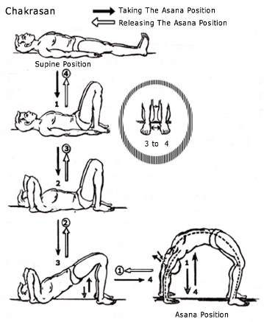
To release the asana pose:
1. Inhale. While exhaling, bend the hands at elbows and legs at knees. Rest the head, the shoulders and then the waist onto the ground. Then touch the back onto the ground.
2. Bring both the palms out from below the shoulders and keep them near the body as in supine position..
3. Straighten out both the legs and come back into the supine position.
Important aspects of the asana pose : This asana is a bit difficult to perform. However, it can be easily performed up to the point one feels possible. The body may not look circular, but the asana can be performed. With constant practice, the ideal position can be achieved. While performing, it is important to straighten out both the legs at the knees and both the hands at the elbows. The neck, at this point should be stretched backwards. The legs, waist, spinal column and hands help in achieving a circular position, hence the bending of the neck has to be in the same direction. The mouth should be closed. The face muscles should be least strained. In the beginning, all muscles in the body have some strain; with a bit of practice it can be reduced. Of course, this takes some time. Initially, while performing the asana, the distance between the two legs can be increased, which facilitates performance as the base is widened. After some practice, the asana can be performed by touching the legs to each other. This, of course, needs quite a bit of study and constant practice.
Duration : This asana results in bending the spinal column in backward direction. Hence, in the initial stages, it is not possible to retain the pose for a long time. However, the pose can be easily maintained for 15 seconds. This is possible with a little bit of practice. After more practice, the duration of this asana can be increased to 2 minutes.
Physical Effects : The asana requires maximum bending of the spinal column on the backside. In daily normal movements, such a bend or strain is not exercised. Hence, this asana yields a bend, which is not normally felt. Generally, we bend towards front, hence our spinal column gets maximum bend towards the front. Exactly opposite pose is achieved in this asana, which definitely improves the efficiency of the spinal column. The reverse bend is felt by all the vertebrae i.e. 33 vertebrae of the spinal column, which increases their efficiency. Increased efficiency also benefits muscles attached to these vertebrae, which participate in the movement. When the bend is exercised, the upper muscles of the abdomen get stretched to the maximum extent. This strain involves a pressure on the internal organs of the abdomen and increases their efficiency. The muscles of the thighs and the calves are also strained to a particular extent and their efficiency increases. When a person does a sedentary job, his spinal column gets accustomed to only particular movements such as bending forward. If such person practices this asana daily, the strain felt by their spinal column due to their daily job will be bearable and will help in decreasing the ailments arising out of it.
Precaution : Persons suffering from spinal column ailments should not practice this asana without expert guidance. Also, first they should try and study ardhachakrasan before attempting this asana. Some persons, though they do not have any disease as such, suffer from stiff spinal column. If an attempt is made to bend the stiff cord, it may lead to injury.
Hence, they should practice the asana only to the extent they can easily perform. Each person should judge his own capability before performing this asana and try to act within the capacity.
References in the ancient texts : No important texts of yoga mention this asana. However, as it is beneficial due to its physical effects, it is invariably mentioned in most of the modern texts. However, no references in the ancient texts are found.

********************

